# Wireframe Design Document – Data Analysis Project

**Document Title:** Wireframe Design  
**Activity ID:** M1.4  
**Date:** 5-4-2025

**Project Team ID:** TP706 – S1 – 2   
**Project Team Name:** Team 2

## 1. Description of the Activity

This activity involves designing the visual layout of key user interface components and dashboards. It helps stakeholders visualize the flow, layout, and structure of the analytical product before development begins. Wireframes can be designed using Figma, drawn on paper, or sketched on a whiteboard and uploaded as images.

## 2. Tools Used

* Figma
* Paper Sketch
* Whiteboard
* Canva
* Other

## 3. Wireframe Snapshots / Upload Area

Screenshot/Image 1:

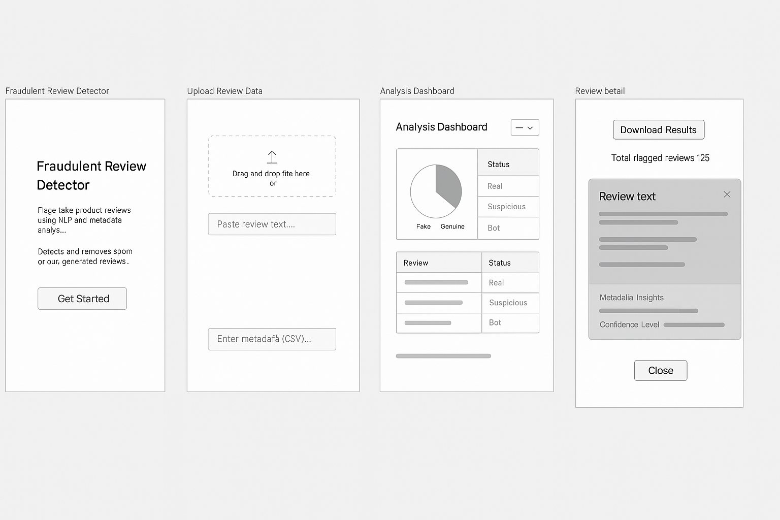

Screenshot/Image 2: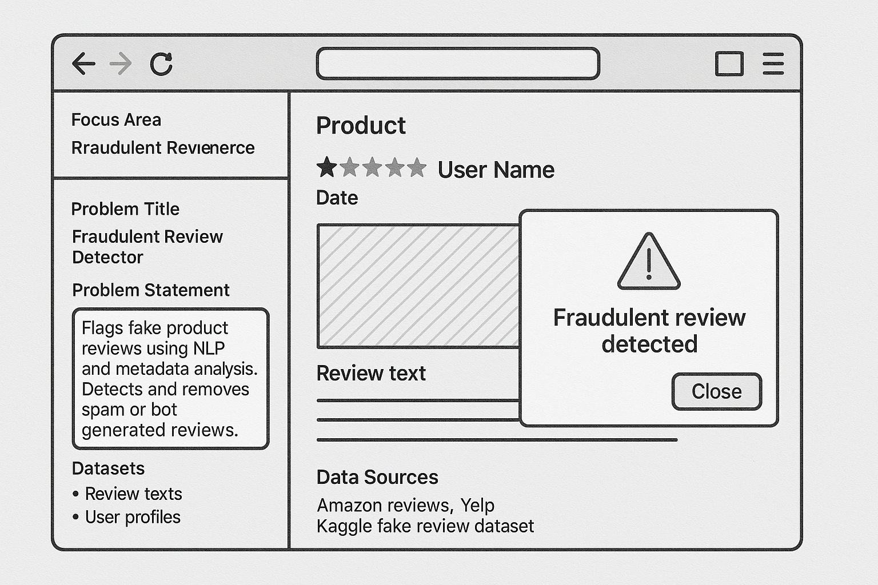

Screenshot/Image 3:

